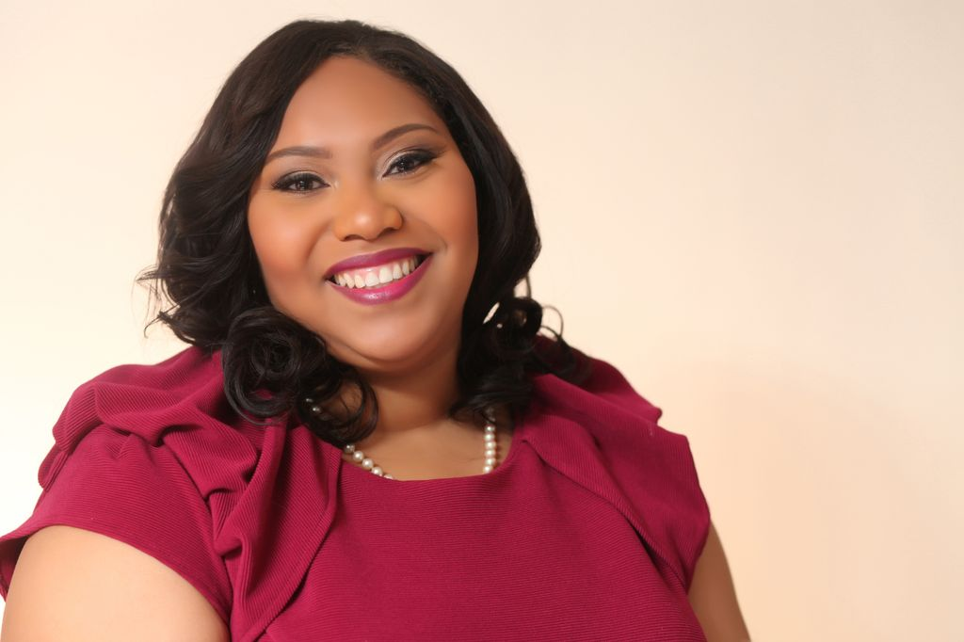
Hello my name is Monica D. Day; I am a lifelong resident of Prince Georges County, Maryland and your 2013 Ms Maryland Plus America. Growing up in a large family that is so close nit has helped shape my outlook on life. If we acted more like a close nit family helping each other through the pathway of life we would be a much better society. My family has certainly helped me through my pathway. They always encouraged me to follow my dreams and assisted me in my education and career efforts. Seeing people in my family achieve their goals and give back to the family and the community has truly inspired me to do the same. I hope my journey to compete in a competition like the Miss Plus America Pageant inspires someone to follow their dreams and aspirations.
I am currently the Political Affairs Coordinator for the American Hospital Association (AHA). At the American Hospital Association I work with the PAC (Political Action Committee) fundraising team. My interest in politics started one summer when I volunteered on a local politician former Congressman Albert R. Wynn’s first congressional campaign in 1992. Since that time I continued to volunteer for other local political campaigns such as former Maryland State Senator Beatrice Tignor’s campaign for Prince Georges County Executive and more recently Maryland Governor Martin O’Malley’s re-election campaign.
Through my years in politics I have gained a love for advocating and raising awareness to issue that align with my political interest. Women’s Health, Small Business, Education and Human Rights are all issues that resonate with my political interest. My career goal is to build my own business where I can help organization shape a grassroots, fundraising and grant programs, so that they can continue to get their message out and help more women in surrounding communities. I want to see more organization become successful in helping women with healthcare, small business ventures, networking, family planning, and continuing education.
I have chosen to represent the Sisters In Spirit Organization because it resonates with my platform of Women’s Empowerment. This organizations mission to help women of all ages focus on health, education, business and spirituality helps to make women more productive in society. My slogan B.E. B.O.L.D. (Brave, Empowered, Body Positive, Optimistic, Leading, Divas) aligns with these issues. Tackling all of these issues on a daily basis shows bravery. By helping each other overcome obstacles like health and economic issues for women can be empowering. Being optimistic and body positive helps women stay spiritually grounded. Being financially literate helps women become better leaders in our families and society. When we add all of these elements up you achieve being a true diva of today. My goal is to help Sisters In Spirit and other organizations like them to grow through fundraising and grassroots efforts.

